‘A high-quality art and design education should engage, inspire and challenge pupils.’
National Curriculum, September 2013.

As part of the art and design teaching sequence the children should ask questions about an artist and evaluate their artwork. The children will then create artwork inspired by that artist.
Across the curriculum there should be a variety of diverse artists for example:

- Both men and woman
- People of colour
- Artists who have a disability
- Neuro diverse artists
- Living and deceased artists
- Artists from across the world
- Local artists

In this document you will find an example art and design curriculum with a range of diverse artists throughout. Then there is a list of artists that could feature in your curriculum with a link to a useful website.

‘Pupil should be taught about great artists, craft makers and designers, and understand the historical and cultural development of their art forms.’
The National Curriculum, September 2013
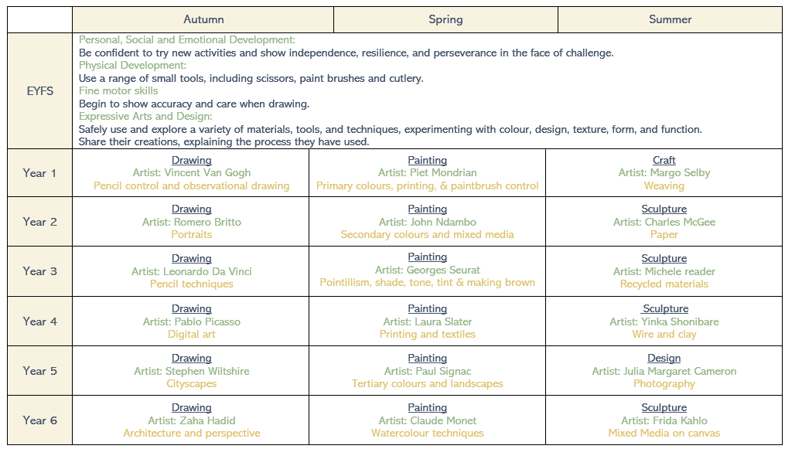

ARTIST | Quote from the ARTIST and link to useful website
PAINTING
  Piet Mondrian | ‘Art is not for anybody and is, at the same time, for everybody.’ - Piet Mondrian  Click link: Piet Mondrian:120 Famous Paintings Analysis & Complete Works (piet-mondrian.org)
  Wassily Kandinsky | ‘Everything starts from a dot.’ - Wassily Kandinsky  Click link: Wassily Kandinsky Paintings, Bio, Ideas | TheArtStory
  Alma Thomas | ‘A world without colour would seem dead. Colour is life.’ - Alma Thomas  Click link: Alma Thomas | Smithsonian American Art Museum (si.edu)
  Georges Seurat | ‘A painting is not created by the artist, but by the eyes of the beholder.’ - Georges Seurat  Click link: Georges Seurat Paintings, Bio, Ideas | TheArtStory
  John Ndambo | ‘Painting is my passion now.’ - John Ndambo  Click link: John Ndambo's Maasai Oil Paintings | African Artwork – True African Art
  Frida Kahlo | ‘Painting completed my life.’ - Frida Kahlo  Click link: Frida Kahlo | Biography, Paintings, & Facts | Britannica
  Maria Sibylla Merian | ‘I am captivated by the intricate patterns and vibrant colours of butterflies.’ - Maria Sibylla Merian  Click link: Maria Sibylla Merian: pioneering artist of flora and fauna | British Museum
Jackson Pollock | ‘I continue to get further away from the usual painter’s tools such as an easel, palette and brushes.’ - Jackson Pollock  Click link: Jackson Pollock: 100 Famous Paintings Analysis and Biography (jackson-pollock.org)
  Yuan Fang | ‘I feel really fortunate to be a female artist at the time we are living in.’ – Yuan Fang  Click link: Interview with Yuan Fang (emergentmag.com)
Claude Monet | ‘Colour is my day long obsession, joy and torment.’ - Claude Monet  Click link: Who is Claude Monet? | Tate Kids
Paul Cezanne | ‘It’s not about painting life, it’s about making paint alive.’ – Paul Cezanne  Click link: Paul Cézanne (1839–1906) | Essay | The Metropolitan Museum of Art | Heilbrunn Timeline of Art History (metmuseum.org)
PRINTING
  Laura Slater | I often feel like I don't have a choice in what I do. It's so much a part of who I am, I really couldn’t do anything else.’ – Laura Slater  Click link: Designer Diary: Laura Slater | Make It In Design
Andy Warhol | ‘Everything has its beauty, but not everyone sees it.’ - Andy Warhol  Click link: Andy Warhol – The Andy Warhol Museum
William Morris | ‘Have nothing in your houses that you do not know to be useful or believe to be beautiful.’ - William Morris  Click link: Introducing William Morris · V&A (vam.ac.uk)
ARTIST | Quote from the ARTIST and link to useful website
DRAWING
  Vincent Van Gogh | ‘If you hear a voice within you say, “you cannot paint,” then by all means paint, and that voice will be silenced.’ - Vincent Van Gogh  Click link: Vincent van Gogh - Van Gogh Museum
  Romero Britto | ‘For me, art can reflect the celebration of the simple and good things in life.’ - Romero Britto  Click link: About (shopbritto.com)
Stephen Wiltshire | ‘Do the best you can and never stop.’ - Stephen Wiltshire  Click link: Stephen Wiltshire - Contemporary Artist & Architectural Illustrator
Georgia O’Keeffe | ‘My painting is what I have to give back to the world for what the world gives to me.’ - Georgia O’Keeffe  Click link: The Georgia O'Keeffe Museum (okeeffemuseum.org)
Adonna Khare | ‘I loved painting and drawing and sculpting and all of that. But I always came back to drawing. It felt like home.’ – Adonna Khare  Click link: Portfolios – Adonna Khare Artist
Leonardo Da Vinci   | ‘Art is never finished, only abandoned.’  Click link: Leonardo da Vinci: Facts, Paintings & Inventions - HISTORY
Paul Klee | ‘A drawing is simply a line going for a walk.’ - Paul Klee  Click link: Paul Klee (1879–1940) | Essay | The Metropolitan Museum of Art | Heilbrunn Timeline of Art History (metmuseum.org)
    Zaha Hadid | ‘I don't think that architecture is only about shelter, is only about a very simple enclosure. It should be able to excite you, to calm you, to make you think.’ – Zaha Hadid  Click link: Zaha Hadid: The 17 Most Striking Buildings by the Architect | Architectural Digest
DIGITAL ART
Roy Lichtenstein | ‘I like to pretend that my art has nothing to do with me.’ - Roy Lichtenstein  Click link: Roy Lichtenstein | MoMA
Banksy | ‘I want to live in a world created by art, not just decorated with it’ - Banksy  Click link: Who is Banksy? Everything we know about the anonymous artist - BBC News
Paul Curtis | ‘I’m hoping to have my own exhibition, but these things don’t just magic up, you have to put a lot of work in.’ - Paul Curtis  Click link: Liverpool Artist | Liverpool | Paul Curtis Artwork
  Pablo Picasso | ‘Every child is an artist.’ - Pablo Picasso  Click link: Pablo Picasso 1881–1973 | Tate
Aske19 | ‘There is nothing more rewarding for me as a portrait artist than the acknowledgement from the subject I paint.’  Click link: Akse P19 | Greater Mancunians
ARTIST | Quote from the ARTIST and link to useful website
SCULPTURE
Michelle Reader | ‘I like to make work that is interactive and inviting, tactile and colourful.’ – Michelle Reader  Click link: Little Creatives Artist: Michelle Reader | Inspire - Culture, Learning, Libraries (inspireculture.org.uk)
Andy Goldsworthy | ‘Ideas must be put to the test. I’ve had what I thought were great ideas that just didn’t work.’ – Andy Goldsworthy  Click link: Biography: Andy Goldsworthy (nga.gov)
  Yinka Shonibare | ‘When it works very well is when you manage to turn the ordinary into the extraordinary.’ – Yinka Shonibare  Click link: Yinka Shonibare CBE RA - Yinka Shonibare CBE RA
Jeff Koons | ‘Art helped give me confidence.’ – Jeff Koons  Click link: Jeff Koons | Pace Gallery
Alberto Giacometti | ‘I've been fifty thousand times to the Louvre. I have copied everything in drawing, trying to understand.’ - Alberto Giacometti  Click link: Foundation Giacometti - Biography (fondation-giacometti.fr)
Charles McGee | ‘Art is everything and everything is art.’ – Charles McGee  Click link: Estate of Charles McGee (lscgallery.com)
Darrell Wakelam | ‘I like to create an atmosphere where children of all ages feel included and important. In this safe and positive environment, they are able to be imaginative and take risks.’ – Darrell Wakelam  Click link: Darrell Wakelam
Matt Buckley | ‘Matt is influenced by style rather than subject, he has given a unique feel to each piece with a dramatic mix of form, light and texture.’ - Matt Buckley - Edge Sculptures | Quay Art (art-gallery-cornwall.co.uk)  Click link: Edge Sculpture | Our Full Collection | Just Sculptures
ARTIST | Quote from the ARTIST and link to useful website
CRAFT and DESIGN
Margo Selby | 'I draw influence from the visual world around me. Colour is the driving force behind my work.’ – Margo Selby  Click link: Margo Selby
Henri Matisse | ‘Creativity takes courage.’ – Henri Matisse  Click link: Henri Matisse: The Cut-Outs | Tate Modern
Robin Brooks | ‘I try to create artwork that can inspire and give us hope.’ – Robin Brooks  Click link: Home : Robin Brooks Art
Julia Margaret Cameron | ‘The capacity for delight is the gift of paying attention.’ – Julia Margaret Cameron  Click link: Who was Julia Margaret Cameron? | KS2 | Primary - BBC Bitesize
  Philip Treacy | ‘I make hats because I love hats.’ – Philip Treacy  Click link: Philip Treacy London

